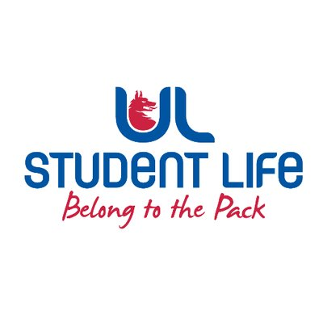
Meeting minutes
UL STUDENT COUNCIL 2023/24 | MEETING 7
Meeting: | UL Student Life – Student Council
Date: | March 5th (Semester 2, Week 6)
Time: | 6:00 PM
Venue: | Library Boardroom
Members: | Ronan Cahill; Ronan Mannix; Emily Rosenkranz; Katie Martin; Roger Dsilva; Emma Wright; Niamh Hickey; Maud Keane; Todor Aleksandrov; Mahir Jha; Lauren Moriarty; Viskwasena Balaji; David Lin; Evan Mansfield; Aine Brady; Shripa Joshi; Edel Straum; Eoghan O’Mahony; Juliette Pinson; Satyam Yadav, Tania Lipper; MD Abrarul Haque Mohsin; Clíodhna Roche; Rhea Edison Alcanther; Prassanna Presath Barani Prasad; Scott O’Brien; Jack Trehy; Amna Basheer; Elliot Buckley; Sara Lee; Kushagra Gupta; Bjorn Vila; Kritney Phartiyal; Leanne Kidney; Patrick Curtin; Dorothy Madden; Alexander De Barra; Kieran Spaight  In Attendance: Maeve Lynes; Dáire Martin.  Apologies :

No. | Items | Responsible | Time
 | Welcome to New Members | Emma | 5 Mins
1. | Minutes and Matters Arising  No matters arising. | Emma | 5 Mins
2. | Meeting Business |  | 5 mins
a. | Executive Reports  - President  - Meeting last week with the President and vice president on breastfeeding awareness.  - PCC board meeting on travel lodge permission 90 more beds.  - Student only gym announcement to be made over the next few weeks.  - Welfare  - Created videos on role to promote for elections.  - Welfare tent over charity week was a massive success.  - Educated students during charity week on drug and alcohol harm reduction.  - Academic  - Irish chamber orchestra – working with communication staff to help boost student engagement.  - Working on the repeat fee’s  - Communities  - Meeting last week with the President and vice president on breastfeeding awareness. Preparing motion  - International women’s day campaign on Friday  - Donation drop off for UNRWA in Student center.  - Student Council Chair  - Ongoing discussions around parking and break-in’s which will be discussed shortly within council.  - Faculties Officer  - No update  - Clubs Officer  - Two policies being discussed within C&S won’t have decision till week 9  - Events Chairperson  - Helped with events throughout charity week.  - Student Experience Chairperson  - No update  - Equality & Diversity Chairperson  - Attended the sensory hour within the library.  - PSU Nominee  - Post grad month completed – was a massive success.  - Traditional night running Thursday  - Societies Officer  - Promoting charity week on socials | Emma | 15 mins
b. | Harm Reduction  - Study drug harm reduction – info students on how sleep is important part of memory retention.  - Drug information on how certain drugs affect you long term and short term. Information will be put out on the effects of certain drugs on your body.  - Interviewing guards on how drug driving impacts you.  - Welfare tent to be set up for race day with information on drug and alcohol awareness | Emily | 5 mins
c. | Water Update  - Spoke to scientist in cork county council staff – filter is placed to filter out the water, but it is not always affective.  - Water is safe in on campus accommodation.  - Ronan to reach out to limerick county council | Darragh O’Connell | 5 mins
d. | ERB Nominations  - Emma to choose and get back to all | Emma | 15 mins
e. | Housekeeping  - Discussed the teams and noted that there is still vacancies within teams | Emma | 15 mins
f. | Election Volunteers  - Please email Maeve.lynes@ul.ie if you are interested in volunteering over elections | Daire/Maeve | 5 mins
3. | AOB  - PVA Volunteer site log hours for your hours in Student council  - PVA meeting 20th March in Common room in Students Union  - Student Forum 10th April to be ratified from March 20th – vote passed | Emma | 5 mins

Duration: 90 Mins | Next Meeting: March 19th (wk8)

